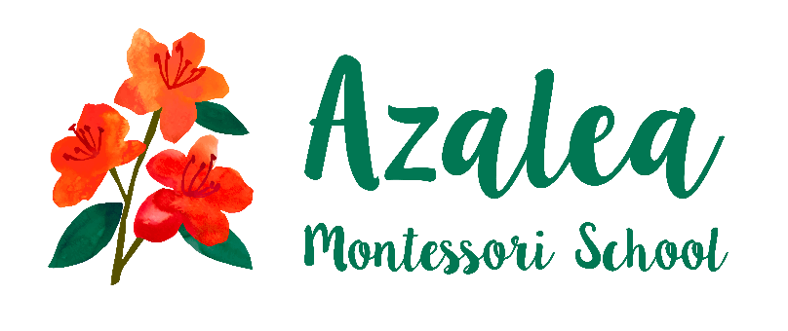

Azalea Montessori School is hiring!

We are looking for a leader for our aftercare program, Azalea Grows. Azalea Grows is a nature-based aftercare program serving the students of Azalea Montessori from 3:00-5:30 Monday-Friday.

Azalea Montessori School is part of the Wildflower Network of schools. We are a micro-school serving preschool and kindergarten children in Norwood. To learn more about our program, please visit www.azalemontessori.org

If you are interested in working in early childhood and are passionate about connecting children to nature, please email
or call Mindie Bell:
mindie@azaleamontessori.org
937-478-2736

