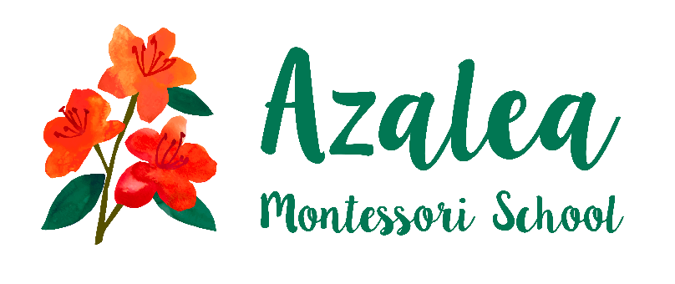
We are seeking an Assistant Teacher to join Azalea Montessori School!
Two experienced Montessori teachers seek a third trained Montessorian to join their team. We serve as both classroom guides and school administrators of Azalea Montessori School. We are located in Norwood and we serve children 3-6 years old.
In addition to an authentic Montessori practice, we value a commitment to equity as well as creating a mindful, peaceful and deeply reflective environment. Openness to personal development, engagement in anti-bias education practices, a dedication to professional evolution, and cultivating children’s direct relationship with the natural world are also part of our ethos. The ideal candidate is someone who is able to effectively extend the values of Montessori to include the adults in our school community and be eager to increase access to quality Montessori education to racially and socioeconomically diverse communities.
We are looking for someone who is willing to play an assistant role during the school day and to take the lead of our nature-based aftercare program after school hours. We are a small school and consistency in teachers and staff is highly valued. We are interested in candidates who are willing to take the lead on projects they are interested in, whether that be community engagement, Montessori practice, or any skills and passions you would like to bring to the Azalea family. Hours for the position are Monday-Friday 8:30 am-4:30 pm. Salary will be in line with experience and qualifications, with opportunities to create other paid programming such as a summer program or vacation care. There is also the option for health insurance and paid personal days. Candidates must hold an early childhood Montessori credential from an MATCE accredited program and be responsible for all state-required trainings such as CPR, First Aid, Communicable Disease Prevention, and Recognizing Child Abuse.
As you would be working with two trained teachers, this would be an excellent learning opportunity for someone who has just completed their Montessori training.
Wildflower is an ecosystem of decentralized Montessori micro-schools that support children, teachers, and parents. Our schools aspire to give all children and families the opportunity to choose high quality, beautiful learning environments as they follow life’s unfolding journey. This is a unique opportunity for someone to be part of Ohio’s first Wildflower School. For more information on Wildflower go to:www.wildflowerschools.org If you are interested, please send cover letter and resume to Jeana Olszewski at jeana@azaleamontessori.org.

